Nurul Taufik Kurrahman

**Task 1**

1. We have already learned how to create DataFrame from files here. Now, we are going to create a DataFrame from a larger csv file on our datasets.

[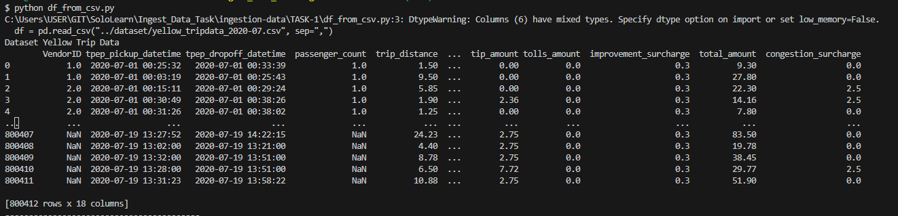](https://github.com/ALTA-DE1-CHARIS-14101996/ingestion-data/blob/main/TASK-1/image-1.png)

1. Rename all the columns with snake_case format.

[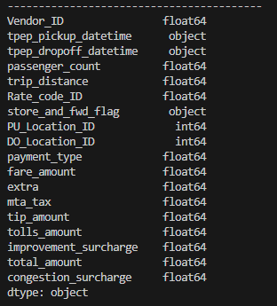](https://github.com/ALTA-DE1-CHARIS-14101996/ingestion-data/blob/main/TASK-1/image-5.png)[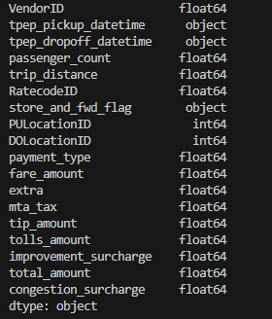](https://github.com/ALTA-DE1-CHARIS-14101996/ingestion-data/blob/main/TASK-1/image-3.png)*Before Rename. *After Rename.

1. [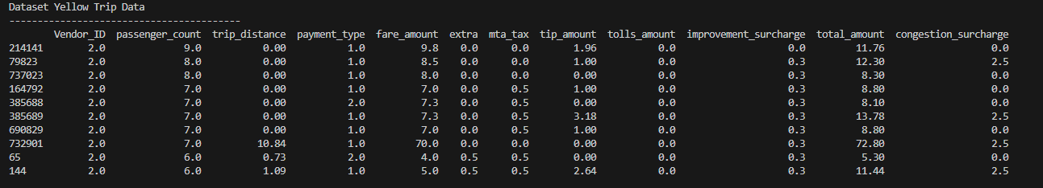](https://github.com/ALTA-DE1-CHARIS-14101996/ingestion-data/blob/main/TASK-1/image-7.png)Select only 10 top of highest number of passenger_count, show only columns vendor_id, passenger_count, trip_distance, payment_type, fare_amount, extra, mta_tax, tip_amount, tolls_amount,improvement_surcharge, total_amount, congestion_surcharge from the DataFrame.
2. [Extra] Cast the data type to the appropriate value.

[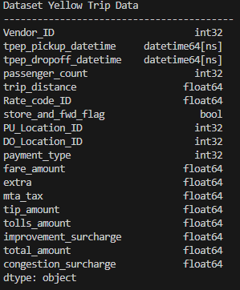](https://github.com/ALTA-DE1-CHARIS-14101996/ingestion-data/blob/main/TASK-1/image-10.png)[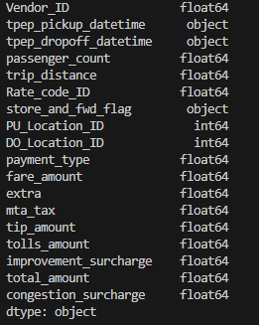](https://github.com/ALTA-DE1-CHARIS-14101996/ingestion-data/blob/main/TASK-1/image-8.png)*Before Change Data Type *After Change Data Type